Work Manager ver1.0

Ho Chi Minh, November 2016

*A - Added M - Modified D - Deleted
Effective Date | Changed Items | A*  M, D | Change Description | New Version
Nov 25, 16 | First release | A |  | 1.0
Nov 29, 16 | Add diagrams | M |  | 1.1

Database
Database will provide features help people manage data contain:
- Add Teams. (Admin)
- Add Users. (Admin)
- Add Members. (Admin)
- Add Works. (Admin)
- Show data. (User)

  - Overall Description
    - Overview
This database will save all information about work of one people (User) contain: ID, Name, Phone, Team, Work Name where user work for.
    - Database diagrams
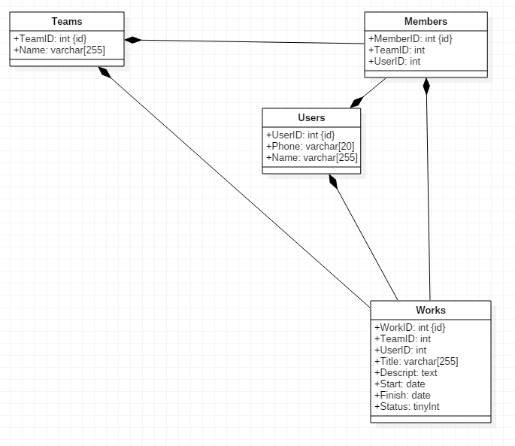
    - Brief Description

Administrator can add information into Teams, Members, Users, Work table.
    - Initial Step-by-Step Description
  - Features
    - Teams
Administrator can add information into Teams table.
      - Use case diagram.
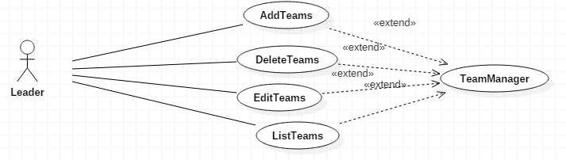
      - Brief Description.

Administrator can add, delete, edit and show list Teams.
    - Members
      - Use case diagram.

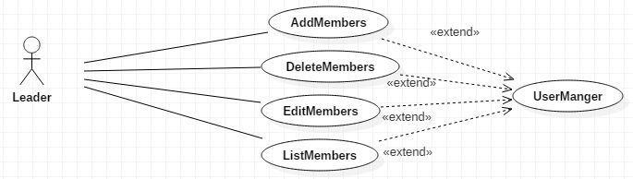
      - Brief Description.

Administrator can add, delete, edit and show list Members.
    - Work
      - Use case diagram.

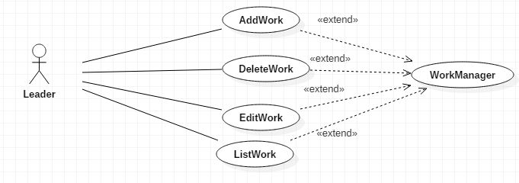
      - Brief Description.

Administrator can add, delete, edit and show list Work.

Manager program
  - Overall Description
    - Overview
This program will setup on manager computer. Manager can Add teams, members, work…
This program save all data upload to server. Manager just work with this program, do not work directly with server.
    - External interfaces
      - Prototype:
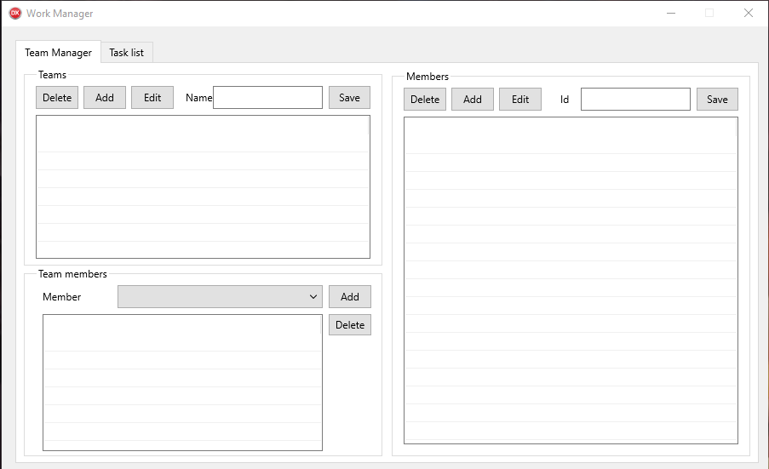

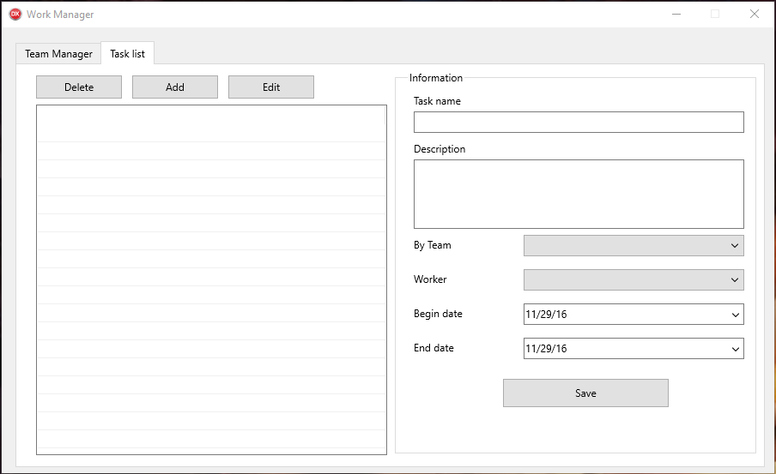
      - Screen description
        - Team Manager
No | Field name | Control type | Data type | Description
1 | Teams | GroupBox |  | This area display all features about Add, Delete, Edit and Save Teams Work by Name.
2 | Team Members | GroupBox |  | This area display all features about Add, Delete member into Teams.
3 | Members | GroupBox |  | This area display all features about  Add, Delete, Edit members by ID.

No | Area | Field name | Control type | Data type | Description
1 | Teams | Delete | Button |  | This button will delete team.
1 | Teams | Add | Button |  | This button will add team.
1 | Teams | Edit | Button |  | This button will edit team.
1 | Teams | Name field | EditBox |  | Default disable.
1 | Teams | Save | Button |  | Save value from Name field.
1 | Teams | DataView | StringGrid |  | Display all teams from server.
2 | Team Members | Member combo box | Combo Box |  | Display all Members get from server.
2 | Team Members | Add | Button |  | Add member into Teams.
2 | Team Members | Delete | Button |  | Delete member from Teams.
2 | Team Members | DataView | StringGrid |  | Display all member participate in Teams.
3 | Members | Delete | Button |  | Delete selected member from server.
3 | Members | Add | Button |  | Add member with ID from ID field.
3 | Members | Edit | Button |  | Edit selected member.
3 | Members | ID field | EditBox |  | Display ID of selected member. Edit when click Edit button.
3 | Members | Save | Button |  | Save value from ID field.

        - Task list
No | Field name | Control type | Data type | Description
1 | Information | GroupBox |  | This area display information about Task name, Description, By Team, Worker, Begin date, End date and Save button.
2 | Delete | Button |  | This button has feature is Delete Task.
3 | Add | Button |  | This button has feature is Add Task.
4 | Edit | Button |  | This button has feature is Edit Task.
5 | Data View | DataGridView |  | This area will display all information about Task.

No | Area | Field name | Control type | Data type | Description
1 | Information | Task name | EditBox |  | Display task name from selected task.
1 | Information | Description | EditBox |  | Display description about selected task.
1 | Information | By Team | Combo Box |  | Display all teams participate with selected task.
1 | Information | Worker | Combo Box |  | Display all members participate with selected task.
1 | Information | Begin Date | Date |  | Display begin date of selected task.
1 | Information | End Date | Date |  | Display deadline of selected task.
1 | Information | Save | Button |  | Save value from all above data field into server.
2 | Left Control | Delete | Button |  | Delete selected task.
2 | Left Control | Add | Button |  | Add task get value from Information GroupBox.
2 | Left Control | Edit | Button |  | Enable Information GroupBox for administrator can edit data.
2 | Left Control | DataView | StringGrid |  | Display all task get from server.

  - Workflow
    - Team Manager
      - Teams
When program run Teams data will load from server. It will display on DataView. When admin click any Team. Teams Name will display to Name field.
Team Members will display all member participate Teams.
Members display all member load from server.
        - Delete
Admin can delete selected Teams. When admin click any Teams from Teams List. Button Delete will enable. Admin can click button Delete. It will delete from server.
        - Add
Admin can add Teams. When admin click Add button. Name field will enable. Admin enter any value into Name field.
Then admin click Save button. All value in Name field will save to server.
        - Edit
Admin can edit selected Teams. When admin click any Team from Teams List. Button Edit and Name field will enable. Admin can change value in Name field. Then admin click Save button, it will replace current Team name and save to server.
        - Save
When admin add new Team or edit Team, Save button will enable.
      - Team Members
Member dataview display all member in current selected team. Member combo box diplay member exclude participated with current Team.
        - Add
When member combo box selected any member and admin click button Add. Member will add to current team.
        - Delete
      - Members
    - Task List
  - Data Format
    - Date/Time Format
Default date format is mm/dd/yy For example: 05/29/14
Default time format is hh:mm:ss For example: 07:23:55
    - Number Format
Order number has no comma separated For example: 12345

